WE ARE LOOKING FOR A
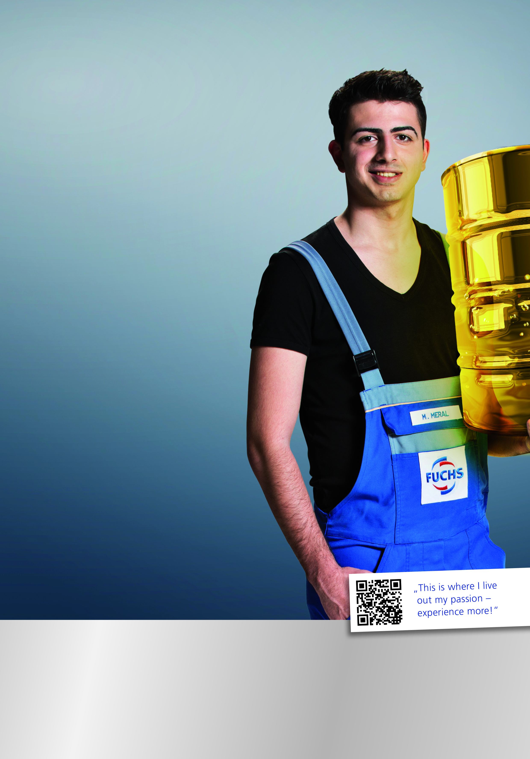
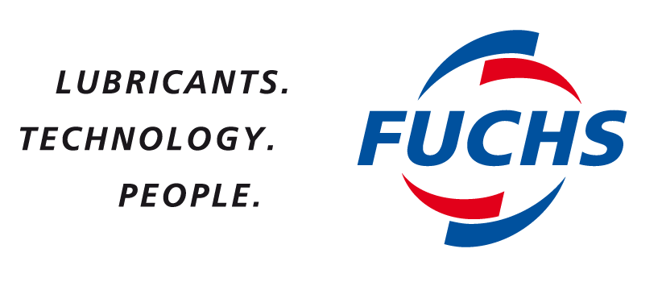
Sales Engineer / Industrial Division (M/F)

WHAT YOU CAN EXPECT

- Responsibility for the promotion of sales of Industrial Lubricants in a defined area through regular customer visits.
- Build up sustainable customer relationships through managing and maintaining the existing customer base as well as expanding the current customer base.
- Developing the Key Account Management Plan and activities.
- Providing technical assistance and arranging successful field trials for various customer applications.
- Maintaining competitive information on price, sales volume and market share as well as competitive market analysis.

WHAT WE EXPECT

- Bachelor degree and sales experience coupled with
good sales and marketing expertise.
- Entrepreneurial spirit.
- Presentation and negotiation skills.
- Good English skills.
- Good skills in data processing (MS Office).
- Honest, reliable and self-motivated personality with
strong and customer oriented communicative and social skills.

If you are interested in developing yourself, please don’t hesitate to contact us and send in your application!

Contact: 66 2615 0168 # 104 or Chompoonuch.s@fuchs.co.th

FUCHS LUBRICANTS (THAILAND) CO.,LTD.
252 SPE Tower 11th Floor, Phaholyothin Road, Samsannai,
Phayathai, Bangkok Thailand

